|  |  |
| --- | --- |
| Use Case UC-6： | User chooses the best way to travel |
| Related Requirem’ts: | REQ3，REQ4，REQ6 |
| Initiating Actor: | user |
| Actor‘s Goal | The user chooses the system to plan the plan that best suits his or her travels. |
| Participating Actors: | Database user |
| Preconditions: | User enters his own destination departure time  The system generates and develops a variety of plans for users to choose |
| Postconditions: | Nothing worth mentioning |
| Flow of Events for Main Success Sccnario: | 1. Multiple optional travel plans appear on the user software interface  2. The user selects one according to their own time and enters 3. After entering, you can view the simulation and see if you are satisfied. |

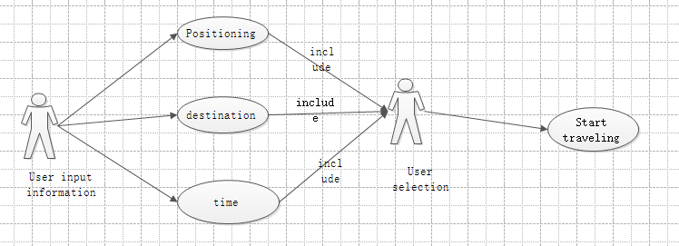

|  |  |
| --- | --- |
| Use Case UC-8： | Modify plan (optional) |
| Related Requirem’ts: | REQ6，REQ8 |
| Initiating Actor: | System |
| Actor‘s Goal | The system selects the avoided road based on the sudden situation of the road condition received by the feedback, and the system regenerates the plan. |
| Participating Actors: | database |
| Preconditions: | The user has feedback on the road condition, and the system receives an unexpected situation in the planned road conditions for the user. |
| Postconditions: | Nothing worth mentioning |
| Flow of Events for Main Success Sccnario: | 1. 1. Have feedback from the user about the road condition or the system collects information about the condition of the road. 2. 2. There are unexpected situations in the planned road conditions of the user in the database. 3. 3. Remind users to regenerate the plan |

